**Pokedex Demo**

**Homepage :**

**Homepage contains search option and every day a pokemon of the day will be shown to the user**

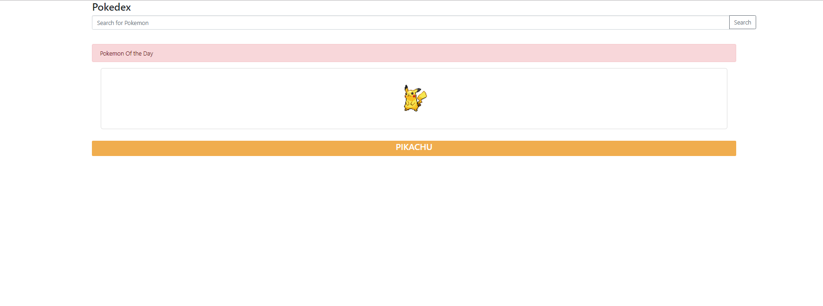

**Search Result Page :**

**This page will show the matching data on the basis of the search query.**

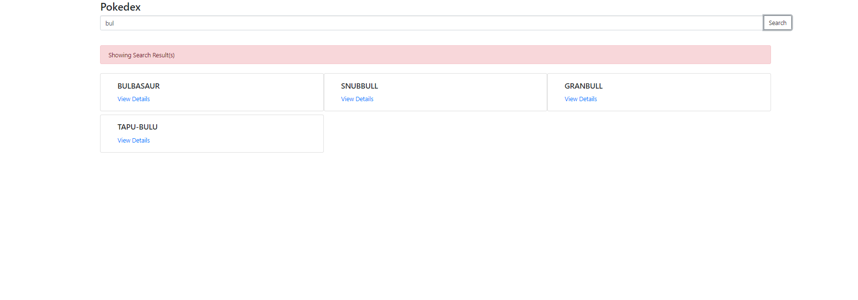

**Details Page :**

**This page will show the details of a particular pokemon.**

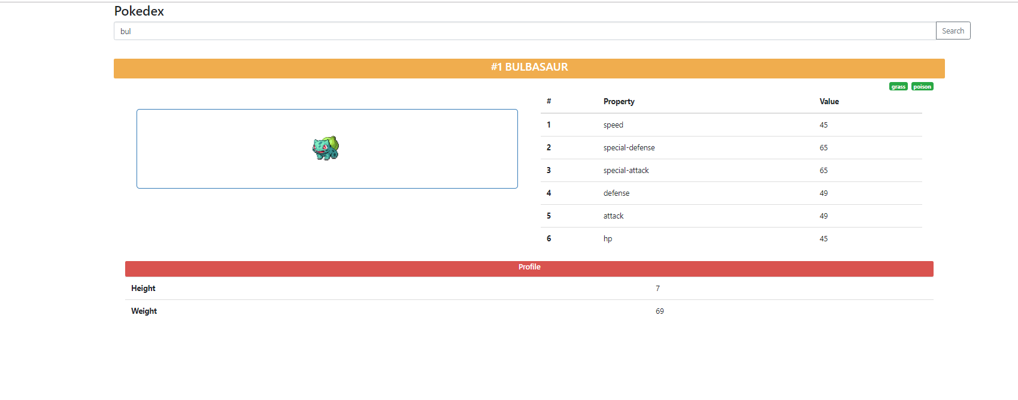

**To run the project , first take the checkout and then in the project directory hit following commans**

1. **Npm I nstall**
2. **Npm start**